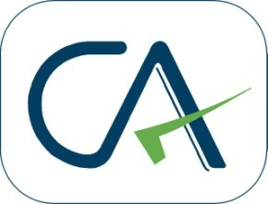
Dinesh Yadav & Co.
CHARTERED ACCOUNTANTS

TO WHOMSOEVER IT MAY CONCERN
NO OBJECTION CERTIFICATE

This is to confirm that I, the undersigned do not have any objection for the below mentioned articled assistant to undergo the AICITSS (MCS) Course in the time and period as mentioned below:

Name | Diksha Yadav
Student Number | CRO0394979
AICITSS (MCS) Venue | Virtually at Dhanbad Branch
AICITSS (MCS) Timings and Dates | 10:30 AM to 4:30 PM  12thMay 2021 to 26thMay 2021

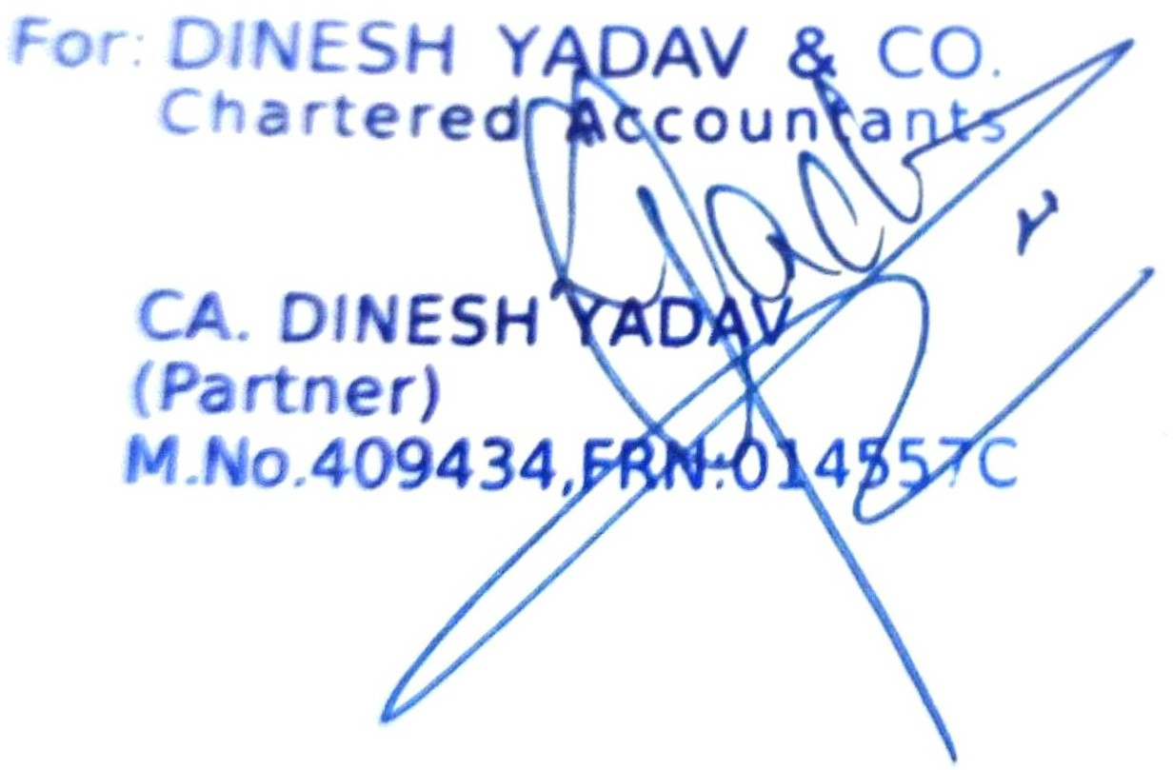

Date:-11.05.2021
Place :- Indore

